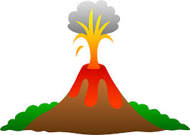


Volcano Research Adventure

Over the next several lessons you will find information about a specific volcano of your choice.

You will gather information and then re-word that information into your own words. Then using your work to create an informational booklet about the volcano you chose.

Volcanoes you can Choose!

- Mount Vesuvius – Destroyed the city of Pompeii
- Krakatoa – Created the loudest sound in all of human history
- Mount St. Helens – The largest eruption in the United States ever
- Eyjafjallajokull – Caused the closure of almost all the airports in Europe
- Olympus Mons – The largest volcano in the Solar System

What you need to research!

- You need to have a map of where your volcano is.
- Details about your volcano like; height, size, type of volcano.
- Pictures of your volcano
- When did it erupt? Does it erupt often? Are any of its eruptions of particular importance?
- When it has erupted was any damage caused by the volcano? Was any one killed?
- Is the volcano still dangerous? Explain why it is or is not dangerous.

Other Information

- No matter what volcano you research you will also need to include in your booklet information about: The three main types of volcano (Cinder Cone, Sheild Volcano and Stratvolcanoes). With a picture of each type, how they are formed, the different ways they erupt and a description of what they look like.

The Booklet

- There is no maximum length to the booklet.
- It can be made in variety of ways. It can be folded A4 paper then stapled in the middle. In can be A4 sheets font and back then stapled in a corner or any way that is appropriate or creative.

Pictures

- Picture must have a label under or next to them to describe what the picture is of. This is so the person reading the booklet knows what they are looking at, an example is below:
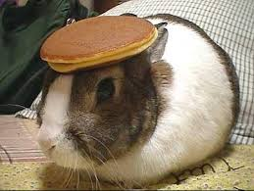

Figure 1.1: A picture of a bunny rabbit with a pancake on its head (right).

- The description has a number so they can be referred to in your paragraphs and if needed a left or a right indicator to tell the reader where the picture is in relation to the label. The picture also has a border.

Criteria

- You will work in individually.
- Do not plagiarise, read all the material you come across then put it into your own words.
- At the end of the booklet put a reference list.

Useful links
- http://ete.cet.edu/gcc/?/volcanoes_types/
- http://en.wikipedia.org/wiki/Olympus_Mons
- http://en.wikipedia.org/wiki/Pumice
- http://en.wikipedia.org/wiki/Obsidian
- http://en.wikipedia.org/wiki/Rhyolite
- http://en.wikipedia.org/wiki/Eyjafjallajökull
- http://en.wikipedia.org/wiki/Mount_St._Helens
- http://en.wikipedia.org/wiki/Mount_Vesuvius
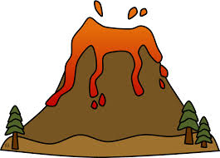
- http://en.wikipedia.org/wiki/Krakatoa

